**Blood bank**

**Management**

**System**

**(BBMS)**

**A**

**MINI PROJECT REPORT**

**ON**

**“Blood bank management system”**

**SUBMITTED BY,**

**Kunal Pramod Chaudhari (24)**

**D.Y. PATIL INSTITUTE OF MCA AND MANAGEMENT**

**AKURDI, PUNE-411044**

Academic Year 2022-2023

Dr. D. Y. Patil Pratishthan’s

D.Y. Patil Institute of Master of Computer Applications

And Management

Sector No.29, Behind Akurdi Railway Station, Pradhikaran, Nigdi, Pune – 411044

Tel No: 020-27640998, 202737393, Fax no: 27653054, Website: www.dypimca.ac.in,

Email: director@dypimca.ac.in

**(Approved by AICTE, Recognized by DTE, Mah.; Affiliated to SPPU)**

**CERTIFICATE**

This is to certify that, the Mini Project entitled

**“Blood bank management system”**

Has been successfully partially completed

By

**Kunal Pramod Chaudhari**

Semester II

Class - FYMCA Div. A

Roll No: 24

M.C.A. (Master of Computer Application)

Academic Year 2022-2023

**Prof. Pranita Manjare Dr.Kavita SuryawanshiDr. K. Nirmala H OD, MCA Director**

**Acknowledgement**

I would take the opportunity to thank **Dr. K. Nirmala, Director, DYPIMCA and Management** for her support, extended to me throughout the course.

I would like to thank **Dr. Kavita Suryawanshi, HOD**, for her scholarly disposition, timely guidance, support and cooperation.

I would like to thank **Prof. Pranita Manjare** for her kind guidance, keen interest, continuous encouragement and inspiration throughout the project work.

Finally, I gratefully thank all the faculty members of DYPIMCA and Management for their cooperation and support.

I also thankful to get constant encouragement, support and guidance from all Teaching and Non- Teaching Staff for their timely support which helped us in successfully completion of our project work.

**Kunal chaudhari.**

Student Name

MCA I year, Div-A

Roll No: 24

**Index-**

|  |  |  |
| --- | --- | --- |
| **Sr. No.** | **Chapter Name** | **Page No.** |
| **1** | **Chapter 1: Introduction** | 6 |
| 1.1 | Project Objectives | 7 |
| 1.2 | Existing System and Need of System | 8 |
| 1.3 | Scope of work | 9 |
| 1.4 | Operating Environment-Hardware and Software | 10 |
| 1.5 | Technology Used | 11 |
| 1.6 | Module Specification | 12 |
| **2** | **Chapter 2: Analysis & Design** |  |
| 2.1 | Data Flow Diagram | 13 |
| 2.2 | Entity Relationship Diagram | 14 |
| 2.3 | Use Case Diagram | 15 |
| 2.4 | Activity Diagram | 16-20 |
| 2.5 | Sequence Diagram | 21-23 |
| 2.6 | Class Diagram | 24 |
| 2.7 | User Interface Screens | 25-44 |
| 2.8 | Table Structure | 45-46 |
| **3** | **Drawbacks and Limitations** | 47 |
| **4** | **Proposed Enhancement** | 48 |
| **5** | **Conclusion** | 49 |
| **6** | **Bibliography** | 50 |

**Chapter 1: Introduction:**

The main aim of this project is to save lives of people by providing blood.

Our project Online Blood Donation Management System using is developed so that users can view the information of near by hospitals, blood banks and volunteer donors.

Project is developed by four perspectives i.e. hospital, blood bank, volunteer donors and patient.

We are developing helps to select the nearby hospitals, blood bank, donors online by location.

This application reduces the time to a greater extent that is searching for the required blood through blood bank band hospitals.

Provides the required information in less time and also helps in quicker decision making.

**Objectives:**

1. The main objective of this specification is to support the automated tracking of blood products from the initial ordering of a blood transfusion for a patient, through to the taking of a blood sample for cross matching, to administration of a blood transfusion and subsequent updates to care records.
2. To allow the probable recipients to make search and match the volunteer donors, and make request for the blood
3. To bridge the gap between blood banks, hospitals, volunteer donors and needy people, through this system.
4. To facilitate the search process for needy people and make it easier than before.
5. Some blood types are rare so the system can find the required donors with the required blood type easily from the huge database
6. To provide dynamic database that is storing donors Information and can communicate with them easily.

.

**Existing system:**

* Difficult to check the blood stock.
* Have to manage lots of paper work.
* Difficult to manage the data.
* Security is week.

**Need of System:**

* **The main aim of this project is to save lives of people by providing blood**
* **Provides the required information in less time and also helps in quicker decision making**
* **We are developing helps to select the nearby hospitals, blood bank, donors online by location**
* **Project is developed by four perspectives i.e. hospital, blood bank, volunteer donors and patient**

**Scope of Work-**

* The system calculates the estimated locations of the donors, hospitals and blood banks.
* The client can also go through from the guideline section to view the useful precautions needed before and after blood transfusion.
* Management of the availability of donors, hospitals, blood banks to the user or member at any time.
* The very friendly design will lead the user to every module very easily without any difficulty.

**Operating Environment-Hardware and Software:**

* Operating system : Windows
* Intel P4 1.5GHz or above.
* 512MB ram.
* 80GB HDD Minimum

**Technology being used:**

▶Frontend: HTML, CSS, JavaScript.

▶Middle end: PHP.

▶Backend: MySQL

**Module Specification:**

* **User management.**
* **Donor management.**
* **Seeker management.**
* **Request information.**
* **Blood donation events.**
* **Blood stock.**
* **Feedback.**
* **User Management:** The system provides security features through username-password matching where only authorized user can access the system with different authorization
* **Donor Information:** Collecting basic information of donor to provide information to receiver
* **Seeker Management:** Collecting information of seekers to suggest them the information of available donors .
* **Request information:** Information or records that’s seeker requirement.
* **Blood donation events:** Information about blood donation camp.
* **Blood Stock Management:** The blood bank staffs can manage the blood stock starting from the blood collection, to blood screening, processing, storage, transference and transfusion through this system.
* **Feedback:** feedback or new suggestion from users.

**Chapter 2: Analysis & Design**

**Diagrams**

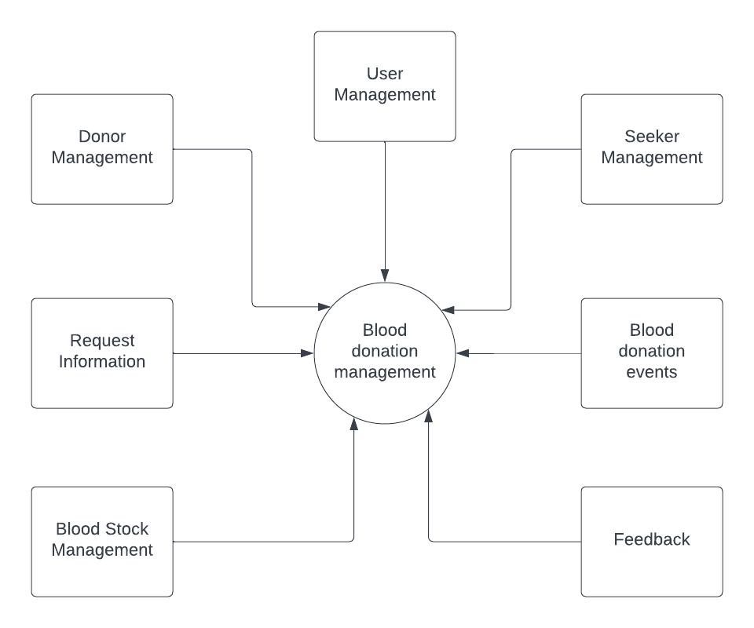Data Flow Diagram (Context Level)

Entity Relationship Diagram:

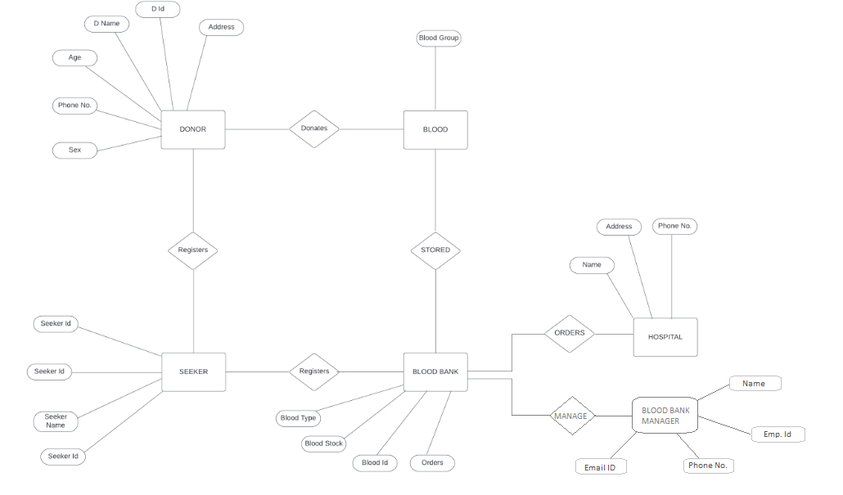

Use Case Diagram:

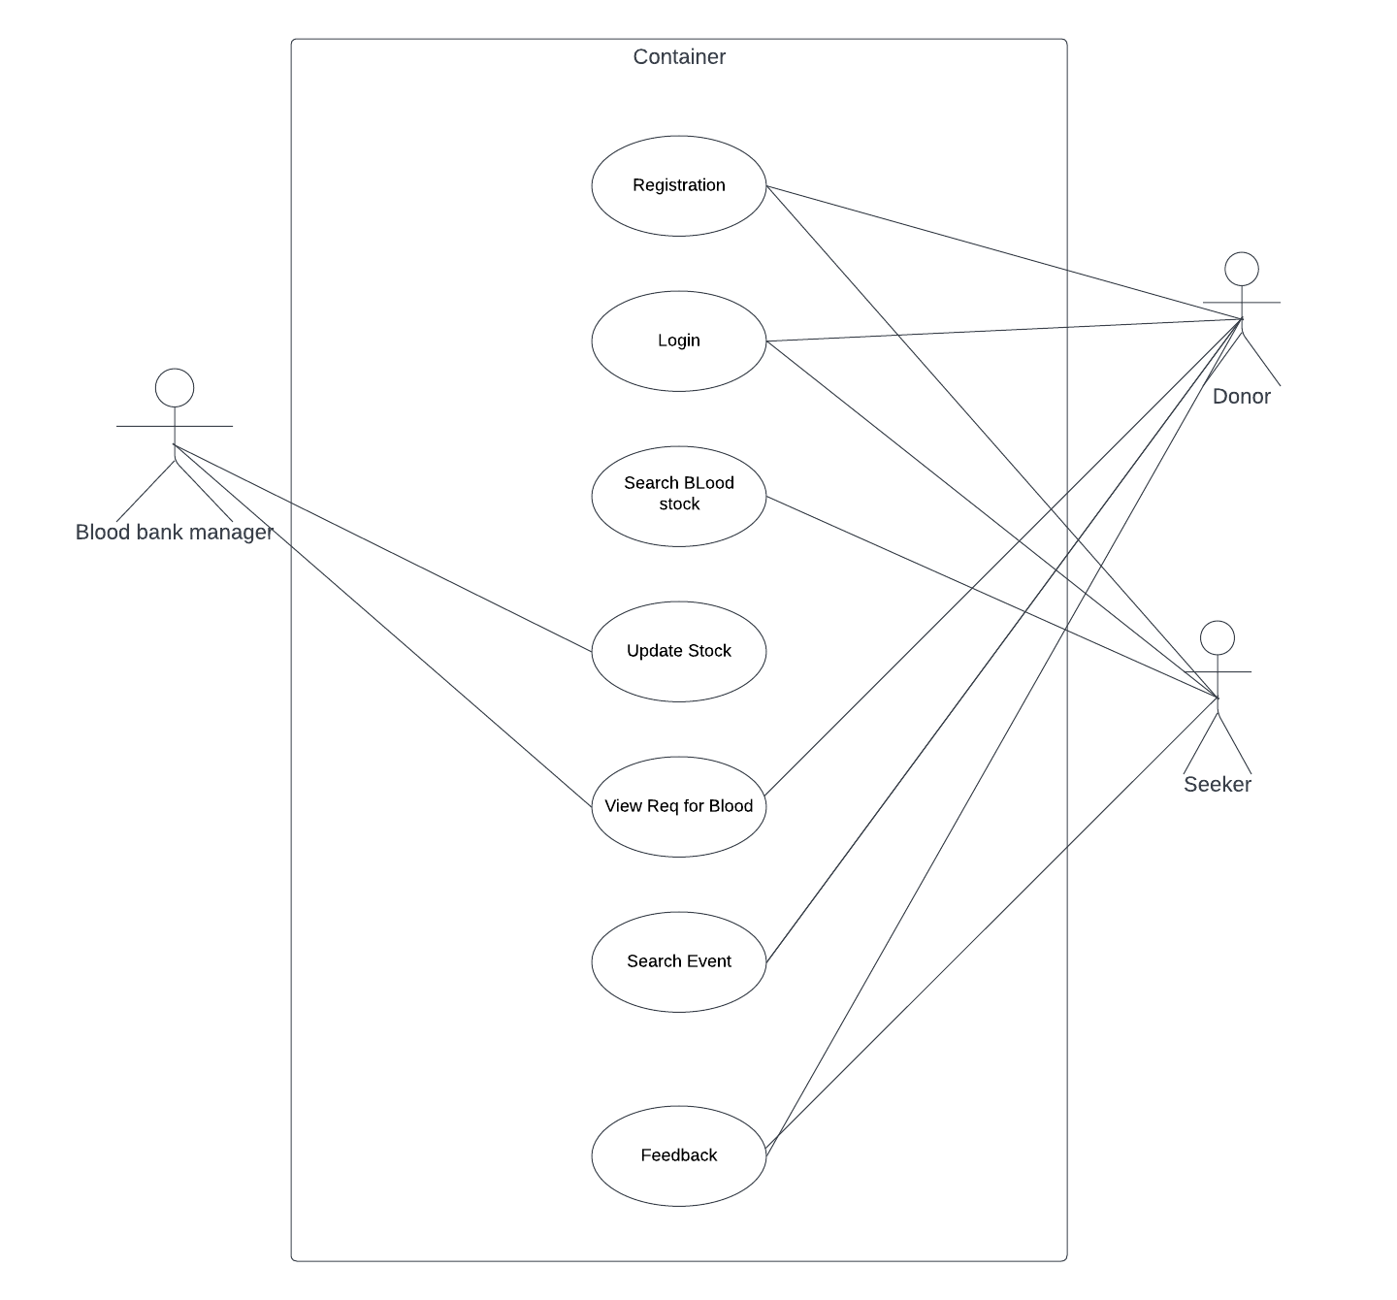

Class Diagram:

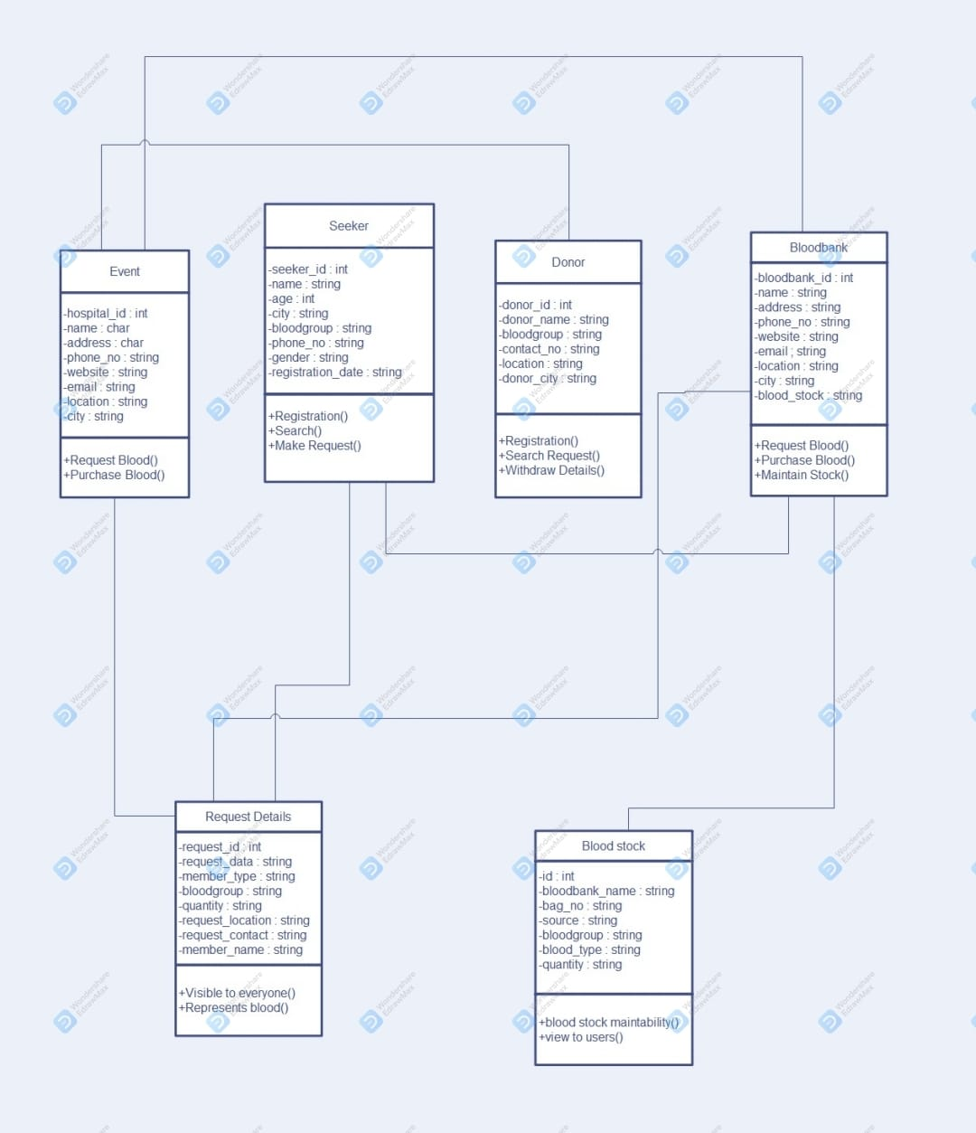

User Interface screen:

Landing Page:

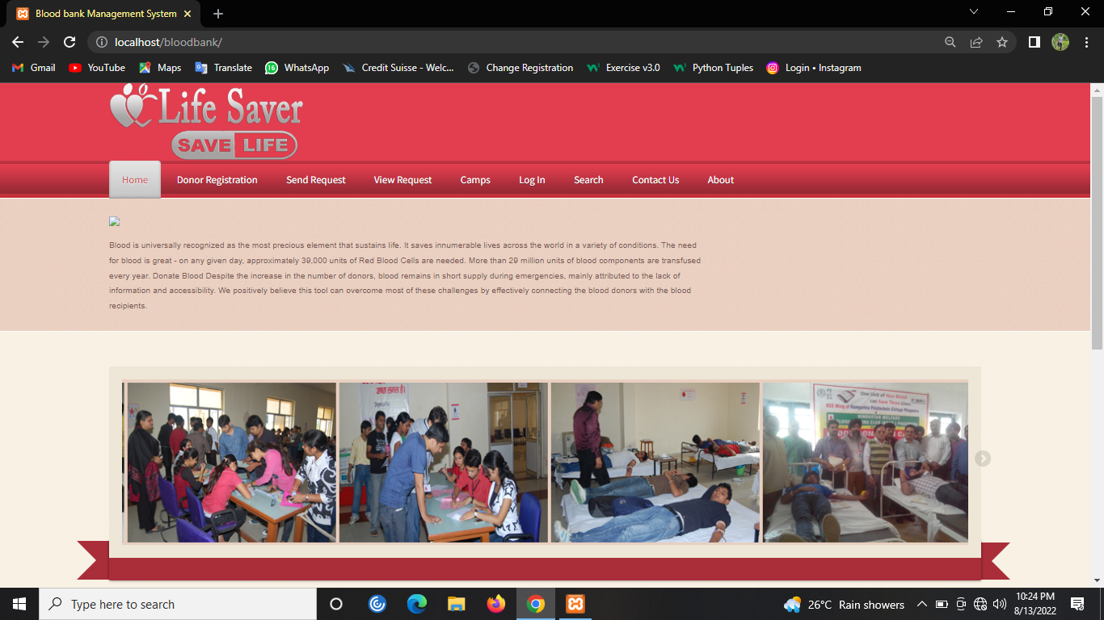

Footer:

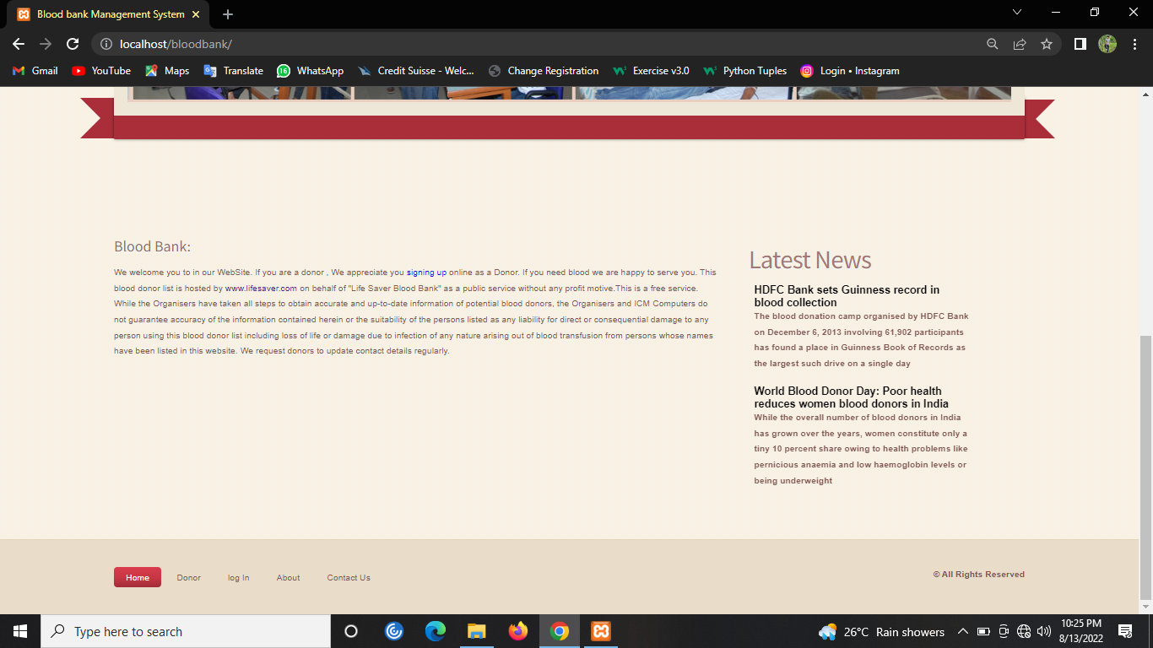

Donar Registration.

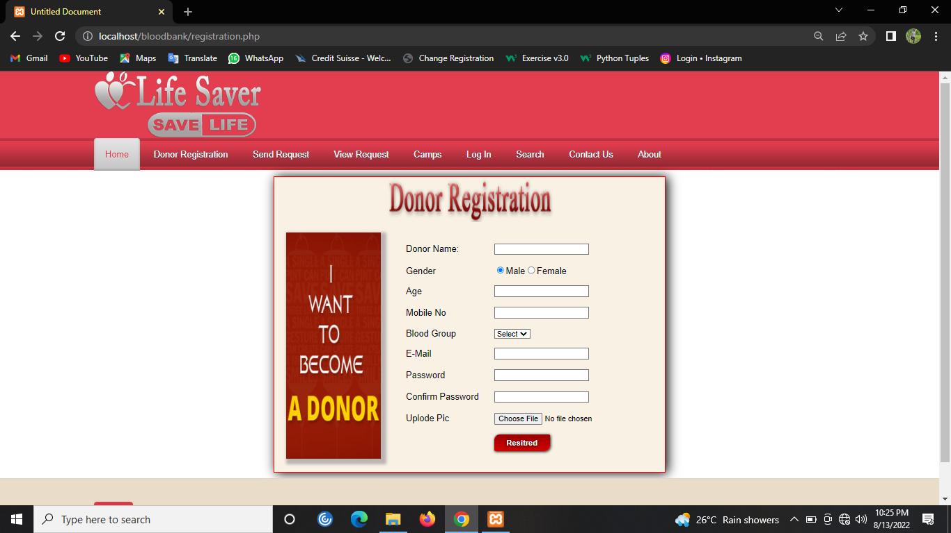

Donar login

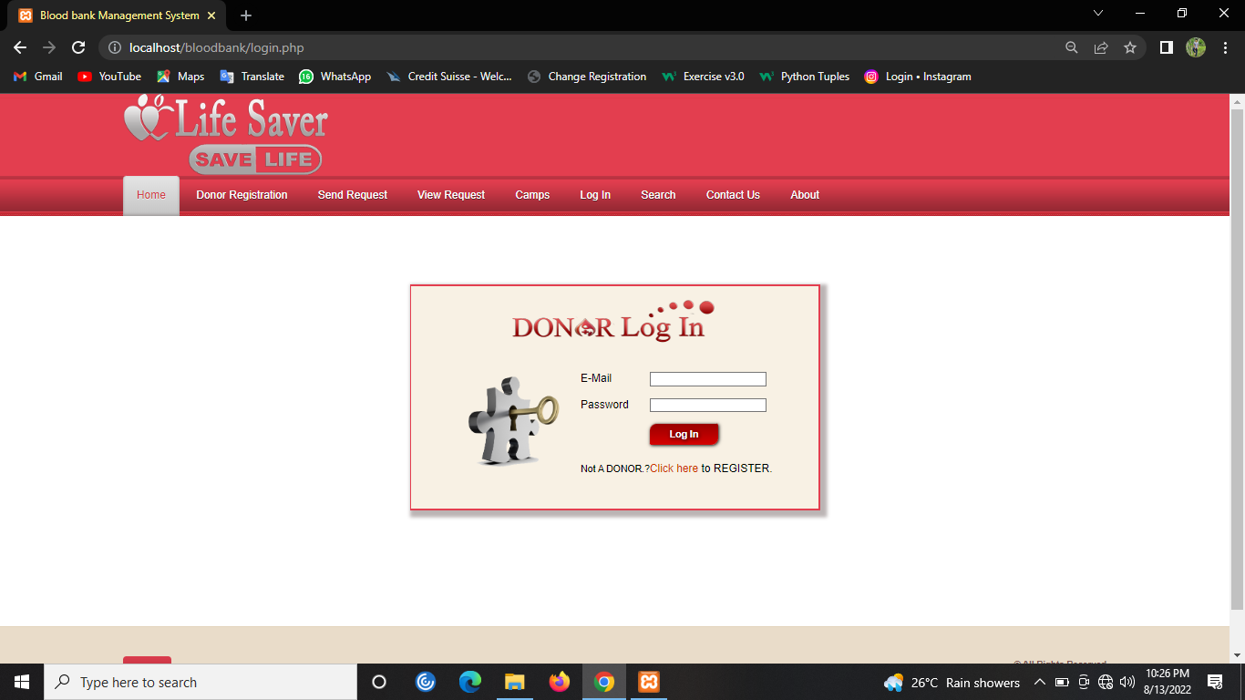

Request for blood.

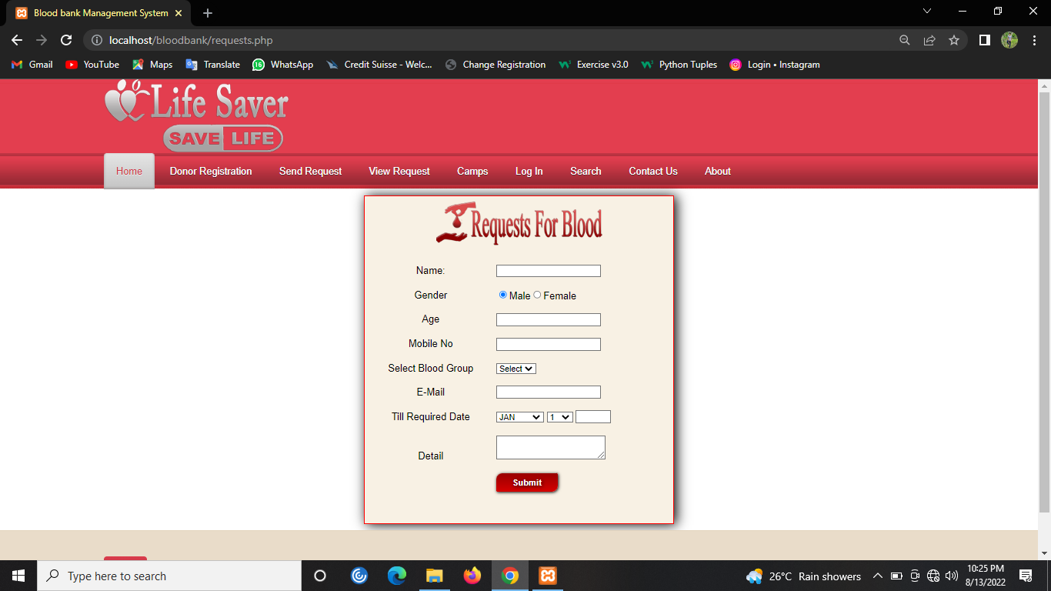

List Of Requested Blood

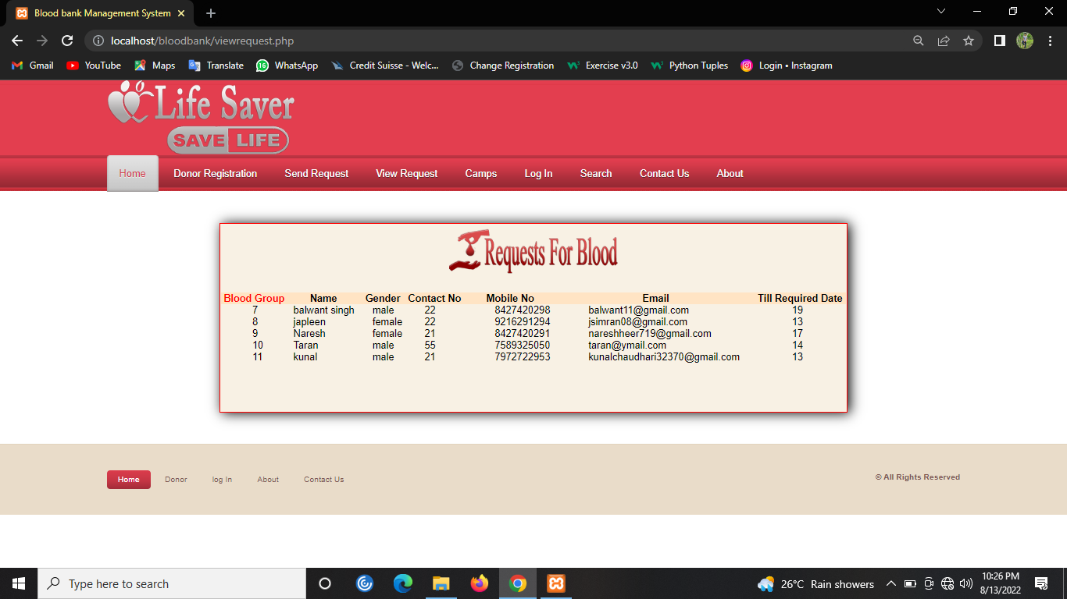

Blood Donation Camp.

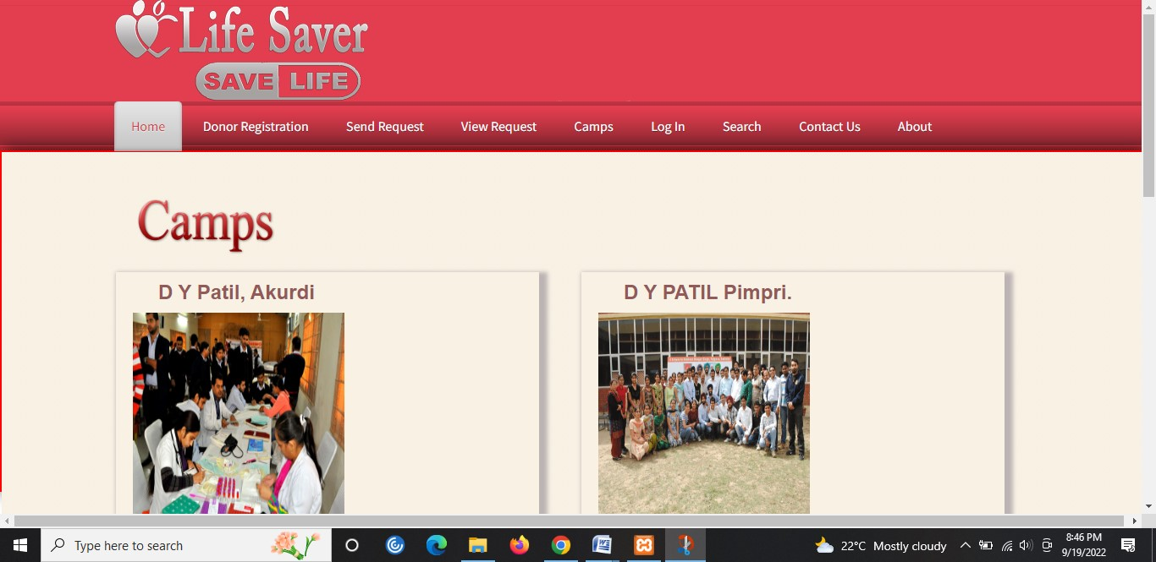

blood search

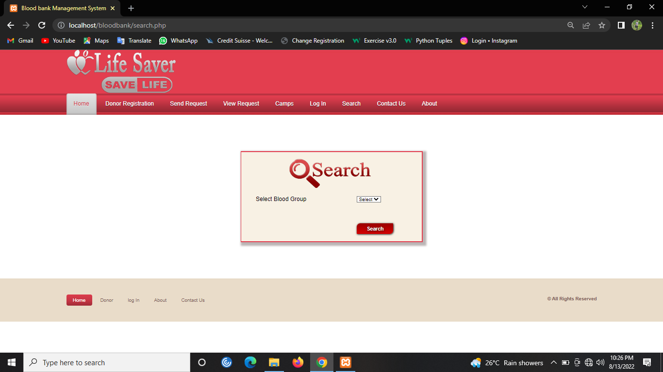

Feedback

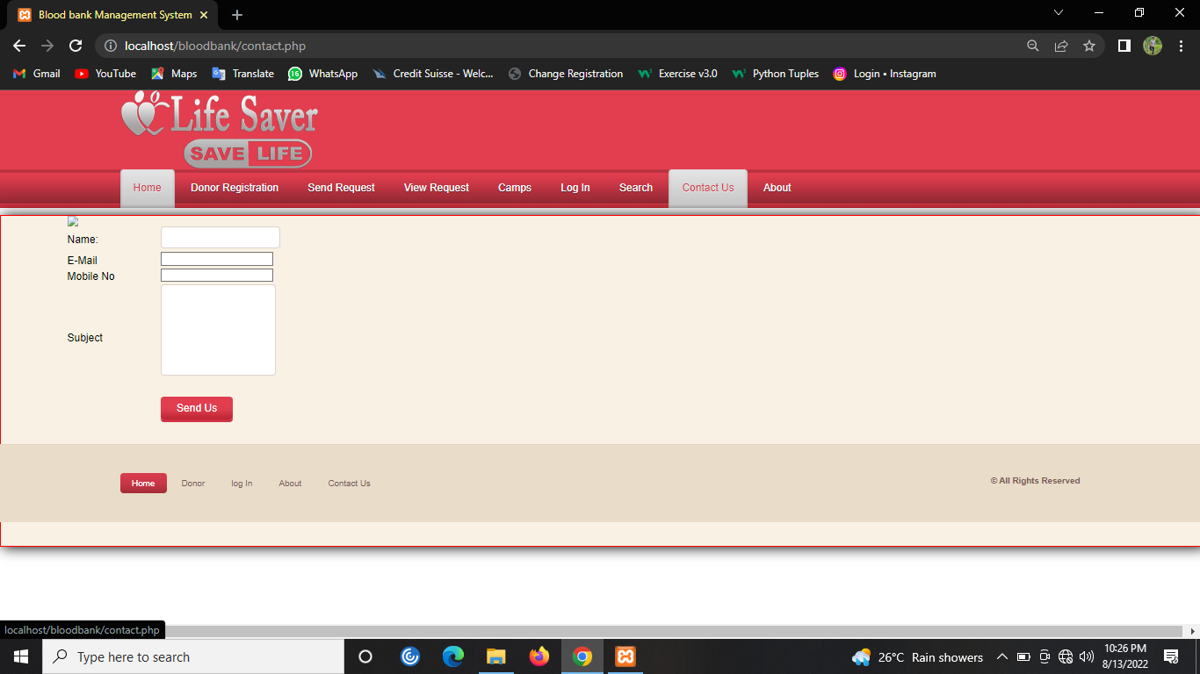

About

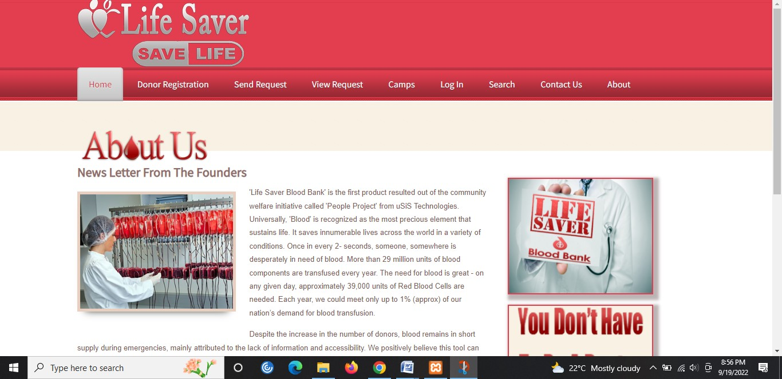

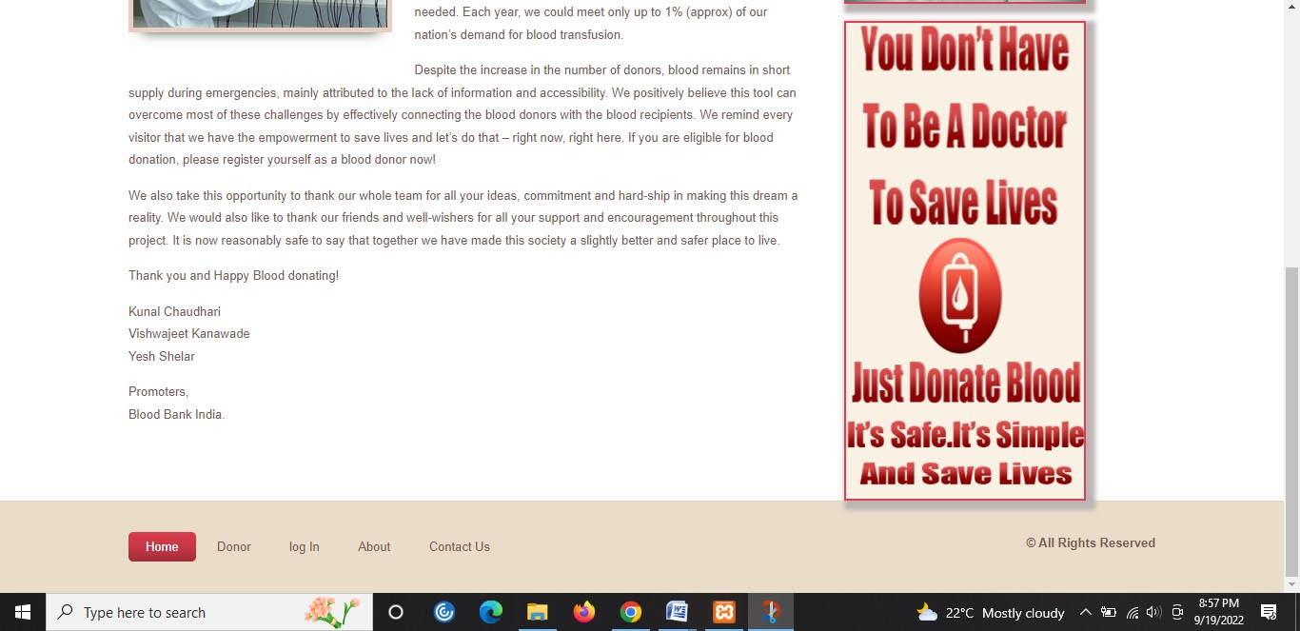

**Sample Project Code:**

Index.html

<!DOCTYPE html PUBLIC "-//W3C//DTD XHTML 1.0 Transitional//EN" "http://www.w3.org/TR/xhtml1/DTD/xhtml1-transitional.dtd">

<html xmlns="http://www.w3.org/1999/xhtml">

<head>

<meta http-equiv="Content-Type" content="text/html; charset=utf-8" />

<title>Blood bank Management System</title>

<link href="css/lightbox.css" rel="stylesheet" />

    <link href="StyleSheet.css" rel="stylesheet" type="text/css" />

    <link href='http://fonts.googleapis.com/css?family=Source+Sans+Pro' rel='stylesheet' type='text/css'>

<link href="css/style.css" rel="stylesheet" type="text/css" media="all" />

<!--slider-->

<link href="css/flexslider.css" rel="stylesheet" type="text/css" media="all" />

     <script src="js/jquery-1.11.0.min.js"></script>

    <script src="js/lightbox.min.js"></script>

<script src="js/jquery-1.7.1.min.js" type="text/javascript"></script>

<script src="js/jquery.flexslider.js" type="text/javascript"></script>

 <script type="text/javascript">

     $(function () {

         SyntaxHighlighter.all();

     });

     $(window).load(function () {

         $('.flexslider').flexslider({

             animation: "slide",

             animationLoop: false,

             itemWidth: 210,

             itemMargin: 5,

             minItems: 2,

             maxItems: 4,

             start: function (slider) {

                 $('body').removeClass('loading');

             }

         });

     });

  </script>

</head>

<body>

 <div class="h_bg">

<div class="wrap">

<div class="header">

        <div class="logo">

            <h1><a href="index.php"><img src="Images/logo.png" alt=""></a></h1>

        </div>

    </div>

</div>

</div>

<div class="nav_bg">

<div class="wrap">

        <?php require('header.php');?>

    </div>

        <div>

          <div class="h_btm_bg">

<div class="wrap">

<div class="h_btm">

    <div class="header-para">

        <img src="cpics/welcome.png"/>

        <p>Blood is universally recognized as the most precious element that sustains life. It saves innumerable lives across the world in a variety of conditions. The need for blood is great - on any given day, approximately 39,000 units of Red Blood Cells are needed. More than 29 million units of blood components are transfused every year.

Donate Blood

Despite the increase in the number of donors, blood remains in short supply during emergencies, mainly attributed to the lack of information and accessibility.

We positively believe this tool can overcome most of these challenges by effectively connecting the blood donors with the blood recipients.</p>

    </div>

    <div class="clear"></div>

</div>

</div>

</div>

<div class="s_bg">

<div class="wrap">

<div class="main_cont">

 <section class="slider">

        <div class="flexslider carousel">

          <ul class="slides">

                <li>

                <img src="Images/slider1.jpg" />

                </li>

                <li>

                <img src="Images/slider2.jpg" />

                </li>

                <li>

                <img src="Images/slider3.jpg"/>

                </li>

                <li>

                <img src="Images/slider4.jpg" />

                </li>

                <li>

                <img src="Images/slider5.jpg" />

                </li>

                <li>

                <img src="Images/slider6.jpg" />

                </li>

                <li>

                <img src="Images/slider7.jpg" />

                </li>

                <li>

                <img src="Images/slider8.jpg" />

                </li>

          </ul>

        </div>

      </section>

    <div class="ribben">

       <div class="l-triangle-top"></div>

       <div class="l-triangle-bottom"></div>

           <div class="rectangle"></div>

          <div class="r-triangle-top"></div>

       <div class="r-triangle-bottom"></div>

       <div class="clear"></div>

    </div>

<div class="main">

    <div class="content">

            <h4>Blood bank:</h4>

            <p>We welcome you to in our WebSite. If you are a donor , We appreciate you <a href="index1.php">signing up</a> online as a Donor. If you need blood we are happy to serve you. This blood donor list is hosted by <a href="index.php">www.lifesaver.com</a> on behalf of "Life Saver Blood Bank"

as a public service without any profit motive.This is a free service. While the Organisers have taken all steps to obtain accurate and up-to-date information of potential blood donors,

the Organisers and ICM Computers do not guarantee accuracy of the information contained herein or the suitability of the persons listed as any liability for direct or consequential damage to any person using this blood donor list including

loss of life or damage due to infection of any nature arising out of blood transfusion from persons whose names have been listed in this website.

We request donors to update contact details regularly.</p>

    </div>

    <div class="sidebar">

            <h2>Latest News</h2>

            <div class="blog_posts">

    <marquee direction="up" scrolldelay="300"><table >

<tr><td>

                         <div class="blog_desc">

                        <div class="blog_heading">

                            <span style="font-weight:bold"><b>HDFC Bank sets Guinness record in blood collection</b>

<p>The blood donation camp organised by HDFC Bank on December 6, 2013 involving 61,902 participants has found a place in Guinness Book of Records as the largest such drive on a single day</p></span>

                         </div>

                         <br />

    <span style="font-weight:bold"><b>World Blood Donor Day: Poor health reduces women blood donors in India</b>

<p>While the overall number of blood donors in India has grown over the years, women constitute only a tiny 10 percent share owing to health problems like pernicious anaemia and low haemoglobin levels or being underweight</p></span>

                      </div>

                        </td></tr>

                </table></marquee>

                     <div class="clear"></div>

                </div>

    </div>

    <div class="clear"></div>

    </div>

</div>

</div>

</div>

        </div>

        <div class="clear"></div>

<div class="ftr-bg">

<div class="wrap">

<div class="footer">

    <div class="f_nav">

        <ul>

            <li class="active"><a href="index.php">Home</a></li>

            <li><a href="donar.php">Donor</a></li>

            <li><a href="login.php">log In</a></li>

            <li><a href="aboutus.php">About</a></li>

            <li><a href="contact.php">Contact Us</a></li>

            </ul>

    </div>

        <div class="copy">

            <p class="title">© All Rights Reserved </p>

        </div>

    <div class="clear"></div>

</div>

</div>

</div></body>

</html>

**Table structure:**

**Table Name: Donar table**

|  |  |
| --- | --- |
| **FIELD NAME** | **DATA TYPES** |
| Donar_id | INT (PRIMARY KEY) |
| name | VARCHAR |
| Gender | VARCHAR |
| Age | INT |
| Mobile | INT |
| B_id | INT |
| Email | VARCHAR |
| pwd | INT |

**Table Name: doantion_table**

|  |  |
| --- | --- |
| **FIELD NAME** | **DATA TYPES** |
| Donation_id | INT (PRIMARY KEY) |
| Date | INT |
| Unit | INT |
| Details | INT |
| Email | VARCHAR |

**Table Name: Request_table**

|  |  |
| --- | --- |
| **FIELD NAME** | **DATA TYPES** |
| Request_id | INT (PRIMARY KEY) |
| name | VARCHAR |
| Gender | VARCHAR |
| Age | INT |
| Mobile | INT |
| Bgroup | VARCHAR |
| Reqdate | INT |
| Detail | VARCHAR |

**Table Name: Camp table**

|  |  |
| --- | --- |
| **FIELD NAME** | **DATA TYPES** |
| Camp_id | INT (PRIMARY KEY) |
| Camp_Title | VARCHAR |
| Organized_by | VARCHAR |
| State | VARCHAR |
| City | VARCHAR |
| details | VARCHAR |

**Table Name: Feedback_table**

|  |  |
| --- | --- |
| **FIELD NAME** | **DATA TYPES** |
| ID | INT (PRIMARY KEY) |
| Name | VARCHAR |
| Email | VARCHAR |
| Mobile | INT |
| subj | VARCHAR |

**Bibliography**

For PHP

* <https://www.w3schools.com/php/default.asp>
* <https://www.sitepoint.com/php/>
* <https://www.php.net/>

**For MySQL**

* <https://www.mysql.com/>
* [http://www.mysqltutorial.org](http://www.mysqltutorial.org/)

**For XAMPP**

* <https://www.apachefriends.org/download.html>